Work Activity:
Organisation Name: |  |  | Prepared By:
Address: |  |  | Date Prepared/revised:

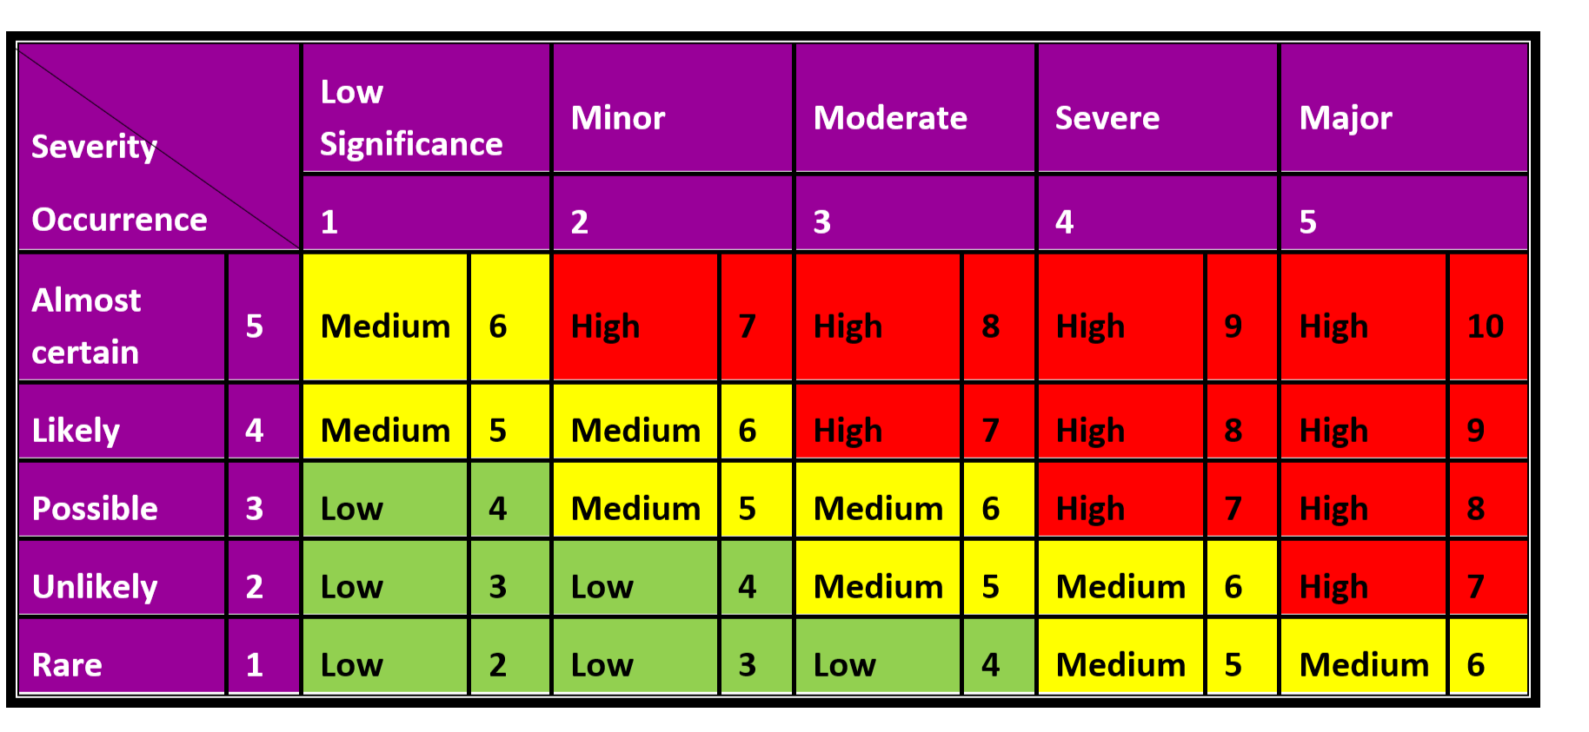
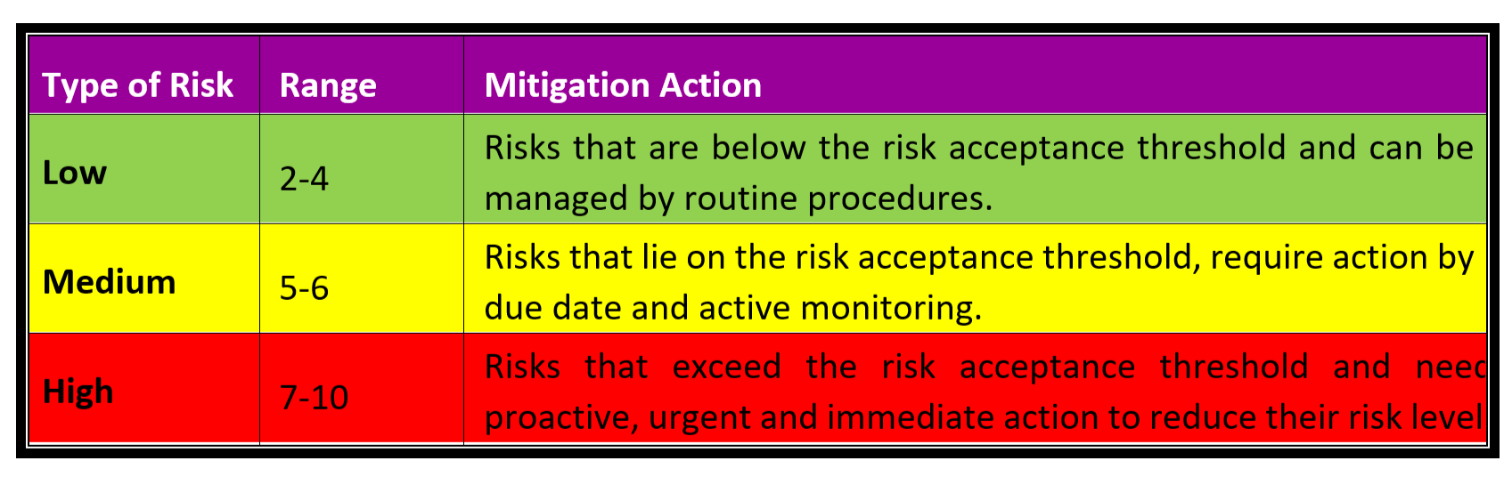
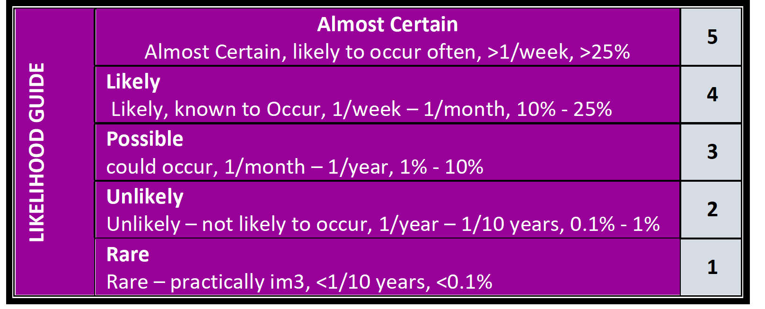

No. | Tasks or Activity or Area | Issue/Hazard/Aspect |  | Risk/Impact | Consequence | Likelihood | RISK SCORE | Control Measures | Person Responsible | Residual Risks
 |  |  |  |  |  |  |  |  |  | Consequence | Likelihood | RISK SCORE
1 | Financial | Significant drop in cash flow |  | Bankruptcy | 3 | 3 | 6 (M) | ➢ Identify operating costs as per future and past performance  ➢ Regular reporting  ➢ Continued financial training and education to key personnel  ➢ Efficient invoicing and debt recovery | Managing Director | 2 | 2 | 4(L)
2 | Human Resource | Shortage of/ Difficulty in recruiting appropriate qualified and skilled staff |  | Customer dissatisfaction / damage to company reputation | 3 | 3 | 6 (M) | - Development of HR policy and procedure  - Offer attractive salary package  - Provide opportunities for career progression  - Develop stimulating and enjoyable working environment  - Commitment to training and development | Managing Director | 2 | 2 | 4(L)
3 | Tenant management | Tenants lack capacity to assert their tenancy rights |  | Harm to other participants | 3 | 3 | 6 (M) | - Communicate tenants rights and responsibilities to them  - To have trained staff to be able to discuss through the situations with tenants and solve the problem | All Workers and Staff | 2 | 2 | 4  (L)
4 | Tenant management |  |  | Loss of tenants | 4 | 3 | 7(H)
5 | Tenant management | Lack of access to high quality complex behaviour support |  | - Implicate the tenancy relationship  - Loss of tenants  - Affect on service provision | 4 | 3 | 7(H) | - Give a notice the participant who is show a behaviour of concern  - Respond quickly to the situation to separate the person with complex behaviour to decrease the harm to other tenants  - Educate staff to respond quickly | Managing Director/ All Workers | 2 | 2 | 4(L)
6 | Tenant management | A lack of knowledge about effective evacuation |  | Harm or injury to tenants and staff | 3 | 3 | 6(M) | - Train staff, tenants and SIL providers with evacuation procedures.  - Conduct and emergency drill | Managing Director/ All Workers | 2 | 2 | 4(L)
7 | Building design | Failing to prevent violence and harm through building design |  | - interpersonal agitation  - Violence and harm to the tenants due to more complex behaviour | 3 | 3 | 6(M) | - Purposeful building design and construction through innovative design that has positive outcomes on tenants behaviour | Management, design and construction team | 2 | 2 | 4(L)
8 | Service agreement | Lack of clarity of responsibilities related to payments and/or property damage |  | - Unreasonable cost of maintenance  - Loss of profit which may end up to bankruptcy | 3 | 3 | 6(M) | - Embed the resolutions for costs of repairs due to complex behaviours in the service agreement  - Train staff to minimise the risk of damage to property and harm to other tenants | Managing Director/ All Workers | 2 | 2 | 4(L)
9 | Service Provision | Principle of choice and Control | Failure to provide tenants to practice their own choice and decision |  | 3 | 3 | 6(M) | Implementing an Independence and Informed Choices Management | Managing Director/ All Workers | 2 | 2 |  | 4(L)
10 |  | Failure in rapid response to tenants needs including urgent repair | - Loss of tenants  - Lack of income |  | 3 | 3 | 6(M) | - Provide temporary accommodation for people being affected to resolve the issue.  - Train staff to respond to the clients needs | Managing Director/ All Workers | 2 | 2 |  | 4(L)
11 | Work Health and Safety | Fire safety and emergency preparedness | - Fatality, Personnel Injury |  | 3 | 3 | 6(M) | - Have emergency response plan in place  - Do not use any source of flame in office/ warehouse. This includes smoking of cigarettes and candles  - Smoke in designated areas only  - Do not overload plug sockets  - Obey the fire and safety instructions  - Switch off and unplug all electrical equipment not in use  - Ensure all cords and cables, including extension cords, are not damaged | Managing Director/ All Workers | 2 | 2 |  | 4(L)
12 | Work Health and Safety | Uneven or slippery surfaces | - Slipping or Tripping causing injury, falling from ladder tipping over |  | 3 | 3 | 6(M) | - Clean mud, grass etc. from boots to prevent slippage  - Good Housekeeping  - Clean spilled materials right away if it can be safely – if not, isolate the area and notify the ap-propriate person.  - Keep the rest area tidy: throw food leftovers etc. in the bins, wipe coffee stains off the table, etc.  - Adequate lighting | Managing Director/ All Workers | 2 | 2 |  | 4(L)
13 | Work Health and Safety | Electrical hazards | - Electrocution/ electric shock |  | 3 | 3 | 6(M) | - Do not use leads and electrical equipment in damp or wet conditions including with wet hands  - Do not use any leads and electrical equipment that are damaged  - Conduct a visual check on the device and electrical leads for faults  - Do not overload socket outlets  - Switch off all plug points that are not in use  - Pull the plug, not the cord, when removing a plug | Managing Director/ All Workers | 2 | 2 |  | 4(L)
14 | Training | Lack of Training | Contractual issues  Unhappy participants  - Business reputation |  | 3 | 3 | 6(M) | - Further training/ refresher on NDIS management system.  - Company will hold regular training sessions to ensure all workers/ staff are up to date and knowledgeable on company processes and procedures. | Managing Director | 2 | 2 |  | 4(L)
15 | Regulatory compliance | - Changes to Acts and other relevant legislation  - Failure to comply with legislation | Damage to Company Reputation/ not compliant support |  | 3 | 3 | 6 (M) | - Review and update Legislative Compliance Register annually  - Training of workers on regulations  - Implementation and monitoring of all policies and procedures  - Effective communication channels with all stakeholders  - Continuous improvement system  - Commitment to training and development  - Regular reviews of all operations  - Restructure service provision if required  - Conducting management meeting  - Induction program | Managing Director | 2 | 2 |  | 4  (L)
16 | tenants | - Failure to deliver services to agreed number of tenants | Damage to Company Reputation |  | 3 | 3 | 6 (M) | - Take early preventive and corrective action if not meeting targets/ expectations  - High quality delivery of all services  - Training of workers  - Attractive fee structures  - Effective market research  - Monitoring of monthly performance  - Maintaining effective relationships with clients  - Maintaining effective communication channels with all stakeholders | Managing Director | 2 | 2 |  | 4(L)
17 | tenants | - Failure to meet and manage tenant’s expectations | Damage to Company Reputation/ Unhappy tenant |  | 3 | 3 | 6 (M) | - Accurate and timely communication with potential and current participants  - Identify the causes and avoid recurrence  - Employing a continuous improvement approach to all operations  - Management of recruitment activities  - Reviewing effectiveness of communication channels with participants  - Conducting management meeting  - Induction program | Managing Director | 2 | 2 |  | 4(L)
18 | COVID-19 | Other staff or customers catching COVID-19 | difficulty breathing or shortness of breath, loss of speech or movement, Death |  | 3 | 3 | M | - Cleaning and disinfecting in accordance with guidance from Safe Work Australia and public health authority.  - Frequently touched surfaces including counters, handrails, doors, till, phones, keyboards and EFTPOS facilities are regularly cleaned.  - Physical distancing  - Alcohol based hand sanitizer is provided at all site  - Follow COVID-19 section of Manual  Make sure all workers wear and use correct PPE | All Employees  Operations Manager | 2 | 1 |  | L
19 | COVID-19 | Sanitizing/infection Cleaning | Staff get infected by COVID 19 |  | 3 | 3 | M | - Only trained cleaners will operate in the infected sited.  - Using Proper PPE as per the Infection Control training | All Employees  Operations Manager | 2 | 1 |  | L

Documentation and Management approval
Completed by: (name) (signature) Authorised by: (name) (signature) Date:

Monitor and review the risk controls
It is important to monitor risk controls and review risk assessments regularly. Review is required when there is a change in the process, relevant legal changes, and where a cause for concern has arisen. Reviews could be scheduled on an annual basis. If the risk assessment has substantially changed a new risk assessment is warranted.
Review date: Reviewed by: Authorised by:
Review date: Reviewed by: Authorised by:
Review date: Reviewed by: Authorised by:
Review date: Reviewed by: Authorised by:
Review date: Reviewed by: Authorised by:

